Software Architecture and Design Specification - Part 2 of 2
Project: AI-Powered Content Management System
Version: 1.0
Authors: < NEURAL NEXUS / Poojitha T, Bhuvanashree S, Harshitha Sai P, Sloka P>
Date: 08-10-2026
Status: Draft
Contents of this part: Security architecture, detailed design, sequence diagrams, API design, error handling, logging and monitoring, UX design, open issues, appendices.

Revision History
Version | Date | Author | Change Summary
1.0 | 08-10-2026 | NEURAL NEXUS | Initial detailed design specification (Part 2)

Introduction to Part 2
This part continues the Software Architecture and Design Specification of the AI-Powered Content Management System (AI-CMS). Part 1 contains the introduction, the component and class diagrams, the component descriptions, the architecture decisions, the technology stack and the data stores; section numbers in this part continue the numbering of Part 1 so that the two parts together follow the template. This part describes how the components work together: it covers the security architecture, the design of the document processing and search functions, the two sequence diagrams, the REST API, error handling, logging and monitoring, and the user interface. Audience: developers, QA engineers, security reviewers, the course instructor and maintenance teams.
Components referred to in this part: Web UI, API Layer, Auth Service, Document Service, Processing Pipeline (Text Extractor, Categorizer, Keyword & Topic Extractor), Embedding Generator, Search Service, Admin Service, Audit Logger and Data Access Layer; data stores: relational database (SQLite with FTS5), vector store (ChromaDB) and file storage.

3. Architecture (continued)

3.9 Security Architecture
Security measures are placed in the API layer (authentication and validation), the service layer (authorization and ownership checks) and the data access layer (parameterised queries). Authorization is always performed on the server (SR-004). All passwords are hashed with bcrypt (SR-002), tokens are signed with a secret key read from the environment (SR-008) and expire after 30 minutes (SR-003). Uploaded files are validated and stored under generated names (SR-005). In deployment, a reverse proxy terminates HTTPS with TLS 1.2 or higher (SR-001).
Threat modelling (STRIDE):
Threat | Example in AI-CMS | Mitigation
Spoofing | Attacker logs in with guessed passwords or reuses a stolen token. | bcrypt password hashing (SR-002), 30-minute token expiry and logout revocation (FR-003), HTTPS.
Tampering | Modified token; malicious or renamed file uploaded; changed request data. | Signed JWT; extension, signature and size checks and generated file names (SR-005); server-side validation.
Repudiation | User denies deleting a document or an administrator denies a change. | Audit log of logins, uploads, deletions and administrator actions (SR-007).
Information disclosure | User reads another user's document by changing the id in a request; sensitive data in logs. | Ownership check on every request returning 404 for foreign documents (SR-004); search restricted to owner's document ids; logs contain no passwords, tokens or document text; HTTPS.
Denial of service | Very large files, many uploads or very long queries. | 10 MB limit, query length limit of 300 characters, background processing, bounded passages per document. (Rate limiting is not implemented in this version.)
Elevation of privilege | Normal user calls administrator endpoints. | Role-based access control on every admin endpoint (FR-004), administrator accounts created only by seeding.

4. Design

4.1 Design Overview
The back end is organised in three layers: API (routers), services and data access. The front end is a separate React application that calls the REST API. The design of the main functions is described below.

Document upload and processing (DS-Doc-01, DS-Proc-01 to DS-Proc-05)
When a file is uploaded the Document Service validates it, saves it, creates the document record with status Uploaded and starts a background task, then returns immediately. The Processing Pipeline then performs the following steps; if any step fails the status becomes Failed and the reason is stored.
- Set status to Processing. Extract text with the Text Extractor; if the text is empty the document fails with 'No extractable text'.
- Store the text and add it to the full-text index (keyword search).
- Split the text into passages of about 150 words with 30 words overlap (at most 100 passages) and compute one embedding per passage in batches.
- Store the passage embeddings in the vector store with the document id.
- Categorization: the document embedding is the mean of the passage embeddings; the category with the highest cosine similarity to the document embedding is selected. Category embeddings are computed from 'name: description' and recomputed when the administrator changes a category. If the best similarity is below the threshold the category is Uncategorized. A category set manually (category_source = manual) is not overwritten.
- Keywords: candidate one- and two-word phrases are taken from the text (English stop words removed); each candidate is embedded and ranked by similarity to the document embedding, using maximal marginal relevance to avoid near-duplicates; the top 10 are stored with their scores.
- Topics: the top 15 candidate phrases are grouped into at most 3 clusters (KMeans on their embeddings); the highest-ranked phrase of each cluster is the topic label. If fewer than 6 candidates exist, the top 1 or 2 phrases are used as topics.
- Save results and set status to Processed.

Search (DS-Srch-01 to DS-Srch-03)
- Both modes first find the ids of the user's Processed documents that satisfy the selected filters (category, file type, date range) in the relational database.
- Keyword mode: the query terms are combined with AND and run against the FTS5 index restricted to those ids; results are ordered by the BM25 rank of FTS5, and the snippet is produced by the FTS5 snippet function.
- Semantic mode: the query is embedded with the same model; the vector store returns the 30 most similar passages among the allowed document ids; passages are grouped by document, the best passage score is the document score; documents below the relevance threshold are dropped; the rest are sorted by score; the snippet is the best-matching passage shortened to about 200 characters; the score is shown as a percentage.
- Results are returned 10 per page. Natural-language queries need no special syntax: the whole text is embedded, which is why relevant documents are found even without shared words.

Data model
The persistent classes are shown in Figure 2 of Part 1. Document.status takes the values Uploaded, Processing, Processed, Failed. Document.category_source takes the values auto or manual. User.role takes the values user or admin. Six default categories are seeded at installation: Technology, Business and Finance, Education, Health and Medicine, Law and Government, Science and Research, each with a description of about 20 words. One administrator account is seeded from environment settings.

4.2 UML Sequence Diagrams
Two sequence diagrams show the two most important flows of the system.
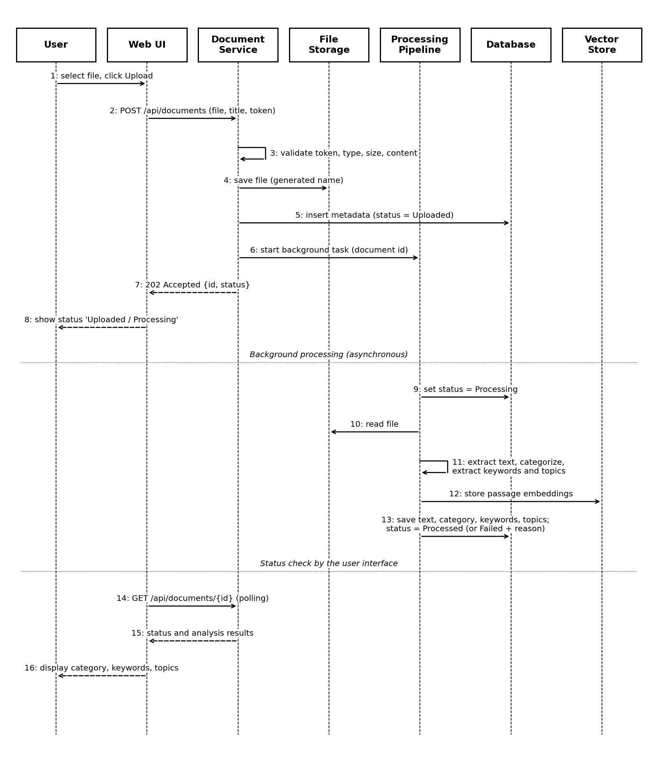
Figure 3: Sequence diagram - Document upload and AI processing (FR-005 to FR-007, FR-013 to FR-018)
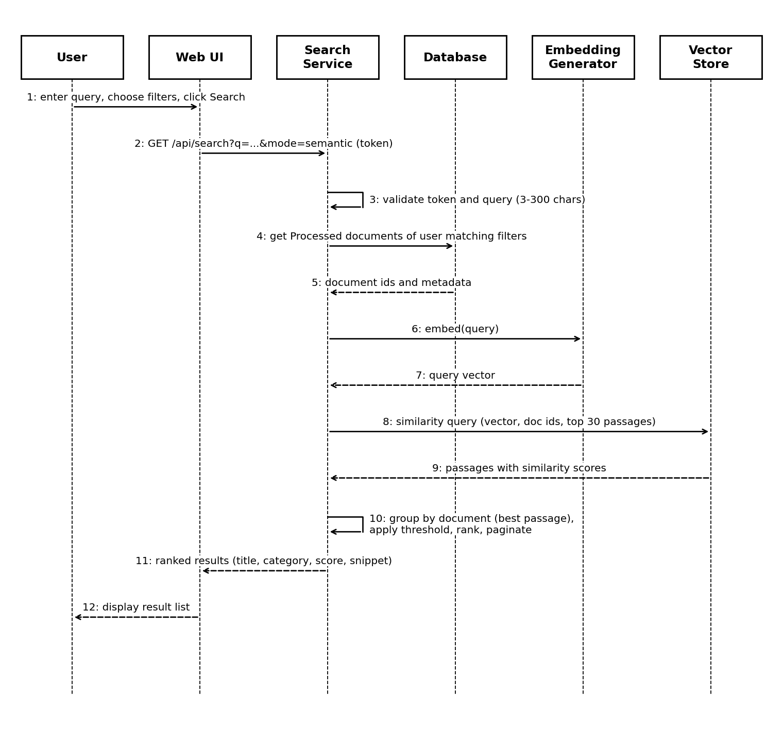
Figure 4: Sequence diagram - Natural-language (semantic) search (FR-021 to FR-023)

4.3 API Design
All endpoints are under /api, use JSON (except upload and download) and require the header Authorization: Bearer <token> unless marked Public. Errors use the format described in Section 4.4. Page parameters: page (default 1) and page_size (default 10).

Auth Service
Endpoint | Method | Request | Response | Errors
/api/auth/register (Public) | POST | {username, email, password} | 201 {id, username, role} | 400 invalid input / weak password; 409 username or email exists
/api/auth/login (Public) | POST | {username, password} | 200 {access_token, token_type, expires_in, role} | 401 invalid credentials
/api/auth/logout | POST | - | 204 No Content | 401 invalid token

Document Service
Endpoint | Method | Request | Response | Errors
/api/documents | POST | multipart: file, title (optional) | 202 {id, title, status: Uploaded} | 401; 413 file too large; 415 unsupported or mismatching type; 422 empty file
/api/documents | GET | page, page_size, sort (upload_date|title), order | 200 {total, page, items[{id, title, file_type, category, status, upload_date}]} | 401; 400 bad parameter
/api/documents/{id} | GET | - | 200 {metadata, category{name, score, source}, keywords[], topics[], text_preview, failure_reason} | 401; 404 not found or not owned
/api/documents/{id}/download | GET | - | 200 original file | 401; 404
/api/documents/{id} | PATCH | {title?, category_id?} | 200 updated document | 401; 404; 422 invalid title or category
/api/documents/{id} | DELETE | - | 204 No Content | 401; 404
/api/documents/{id}/reprocess | POST | - | 202 {id, status: Uploaded} | 401; 404; 409 already processing
/api/categories | GET | - | 200 [{id, name, description}] | 401

Search Service
Endpoint | Method | Request (query parameters) | Response | Errors
/api/search | GET | q (3-300 chars), mode (keyword|semantic, default semantic), category_id, file_type, date_from, date_to, page, page_size | 200 {total, page, items[{id, title, category, file_type, upload_date, score (semantic only), snippet}]} | 401; 400 query length or filter value invalid

Admin Service (Administrator role required; 403 for other roles)
Endpoint | Method | Request | Response | Errors
/api/admin/categories | POST | {name, description} | 201 category | 401; 403; 409 duplicate name; 422
/api/admin/categories/{id} | DELETE | - | 204 (documents become Uncategorized) | 401; 403; 404
/api/admin/audit-log | GET | page, page_size | 200 {total, items[{time, user, action, details}]} latest first | 401; 403
/api/health (Public) | GET | - | 200 {status: ok} | -

4.4 Error Handling, Logging & Monitoring
Error handling. All errors are returned as JSON {"error": {"code": "...", "message": "..."}} with a suitable HTTP status (400, 401, 403, 404, 409, 413, 415, 422, 500). Messages are readable by users and do not contain stack traces, file paths or SQL. Login failures use one generic message. Requests for documents of another user return 404. Unexpected exceptions are caught by a global handler, logged and returned as 500 with a generic message. Errors in background processing never reach the user as exceptions: the document gets status Failed and a short reason (for example 'No extractable text', 'File is corrupted or password protected', 'Processing error'), which the user sees on the details page and can retry with reprocess.
Logging. The application writes a rotating log file with timestamp, level, module and message. INFO: start-up, requests summary (method, path, status, duration), processing start/end with duration per document. WARNING: validation failures, failed logins. ERROR: exceptions with stack trace (in the log file only). The audit log table records the events of SR-007. Passwords, tokens, extracted document text and full file contents are never logged.
Monitoring. A /api/health endpoint reports that the application is running. Documents that failed processing are shown to their owner in the document list with the failure reason. The processing duration logged for each document and the request durations in the log are used to check NFR-001 and NFR-002. No external monitoring tools are used.

4.5 UX Design
The interface is kept simple with a top navigation bar (Documents, Search, and for administrators Admin) and a logout button.
Screen | Content and behaviour
Login / Register | Two simple forms with labelled fields and inline error messages. After login the user goes to the document list.
Documents | Upload form (file chooser, optional title, Upload button) above a table of documents (title, type, category, status, date). Status is shown as text (Uploaded, Processing, Processed, Failed); the list refreshes every 3 seconds while any document is not Processed or Failed. Sorting by title or date, paging, and Open/Delete links. Delete asks for confirmation.
Document details | Metadata, category with score and a dropdown to change it, keywords, topics, text preview, failure reason if any, and buttons Download, Edit title, Reprocess, Delete.
Search | One search box, a choice between 'Natural language' (default) and 'Keyword', and filters for category, file type and date range. Results show title, category, type, date, snippet and score, with paging. If nothing is found a message suggests trying different words.
Admin pages | Categories (list with add and delete) and Audit log (paged table).

Accessibility and usability: every input has a visible label, all functions can be reached with the keyboard, text and background have high contrast, error and status messages are shown in text (not by colour alone), and the layout works at a width of 1280 pixels or more.

4.6 Open Issues & Next Steps
- The initial thresholds (category 0.30, semantic relevance 0.25) must be tuned using a development set of documents before the final evaluation.
- Check whether the 150-word passage size gives good snippets and relevance; adjust if needed.
- Decide the exact text-extraction library for PDF (pdfplumber or PyMuPDF) after a speed and quality test on sample files.
- Next steps: set up the repository and environment, implement the authentication and document modules, implement the processing pipeline with the sample document set, implement search, build the user interface, then prepare the evaluation data and tests.
- Possible future enhancements (not part of this version): OCR for scanned documents, support for more languages, combining keyword and semantic scores, sharing documents between users, rate limiting.

5. Appendices
5.1 Glossary: AI, NLP, API, REST, JWT, RBAC, ADR, STRIDE, TLS, FTS5 (SQLite full-text search), BM25 (ranking function of FTS5), KMeans (clustering algorithm), MMR (maximal marginal relevance), embedding, passage, vector store, cosine similarity.
5.2 References: IEEE 42010 (architecture description), OWASP Top 10 and OWASP ASVS, NIST SP 800-160, Reimers and Gurevych, Sentence-BERT (the basis of sentence-transformers), FastAPI, ChromaDB and SQLite FTS5 documentation.
5.3 Tools: draw.io or PlantUML for diagrams, Swagger UI (automatically provided by FastAPI) for API documentation, Postman for API testing, Git and GitHub for version control.

